LAB 4: LAN

**LAB 4.1: UNDERSTANDING, CREATING AND SIMULATING PEER-TO-PEER NETWORK COMMUNICATION BY USING PACKET TRACER.**

**OBJECTIVE:**

* To understand and simulate the Peer-to-Peer network

**SOFTWARE USED:**

* Packet Tracer

**BACKGROUND:**

Peer-to-peer (P2P) network is a type of autonomous network architecture in which network participants, or peers, exchange resources and interact directly with one another without the need for a centralized server or authority. Every participant in a P2P network can act as both a client and a server, allowing peers to share files, data, or services directly.

**TOPOLOGY:**

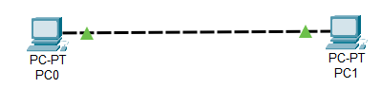

IP Addressing Plan:

|  |  |  |  |  |  |
| --- | --- | --- | --- | --- | --- |
| Device | Interface | IP address | Subnet Mask | VLAN | Default gateway |
| PC0 | NIC | 192.168.10.101 | 255.255.255.0 |  |  |
| PC1 | NIC | 192.168.10.102 | 255.255.255.0 |  |  |

**PROCEDURE:**

1. Open the Cisco packet tracer whose lookback interface looks as the figure below.

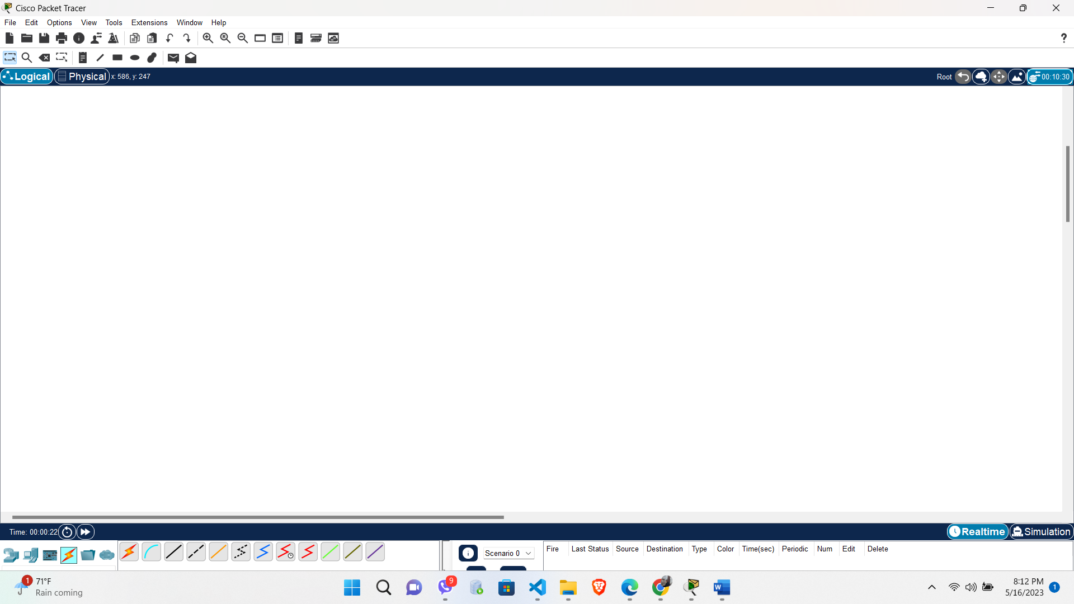

1. Add two computers, by dragging the PC icon from the leftmost bottom until it looks like:

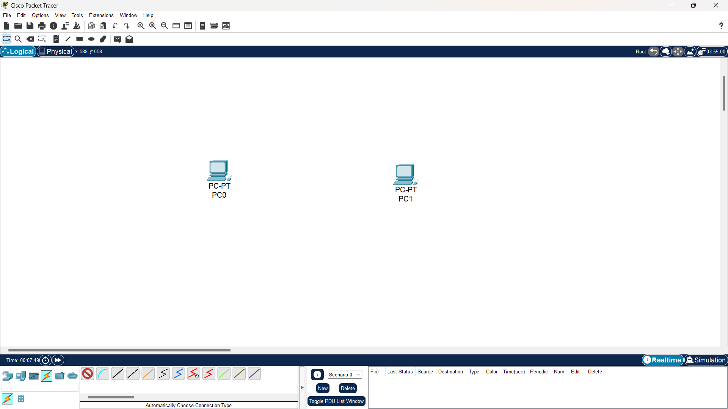

1. Then, use cross- over cable to connect two PCs or you can directly use an automatic cable so that it will look like this:

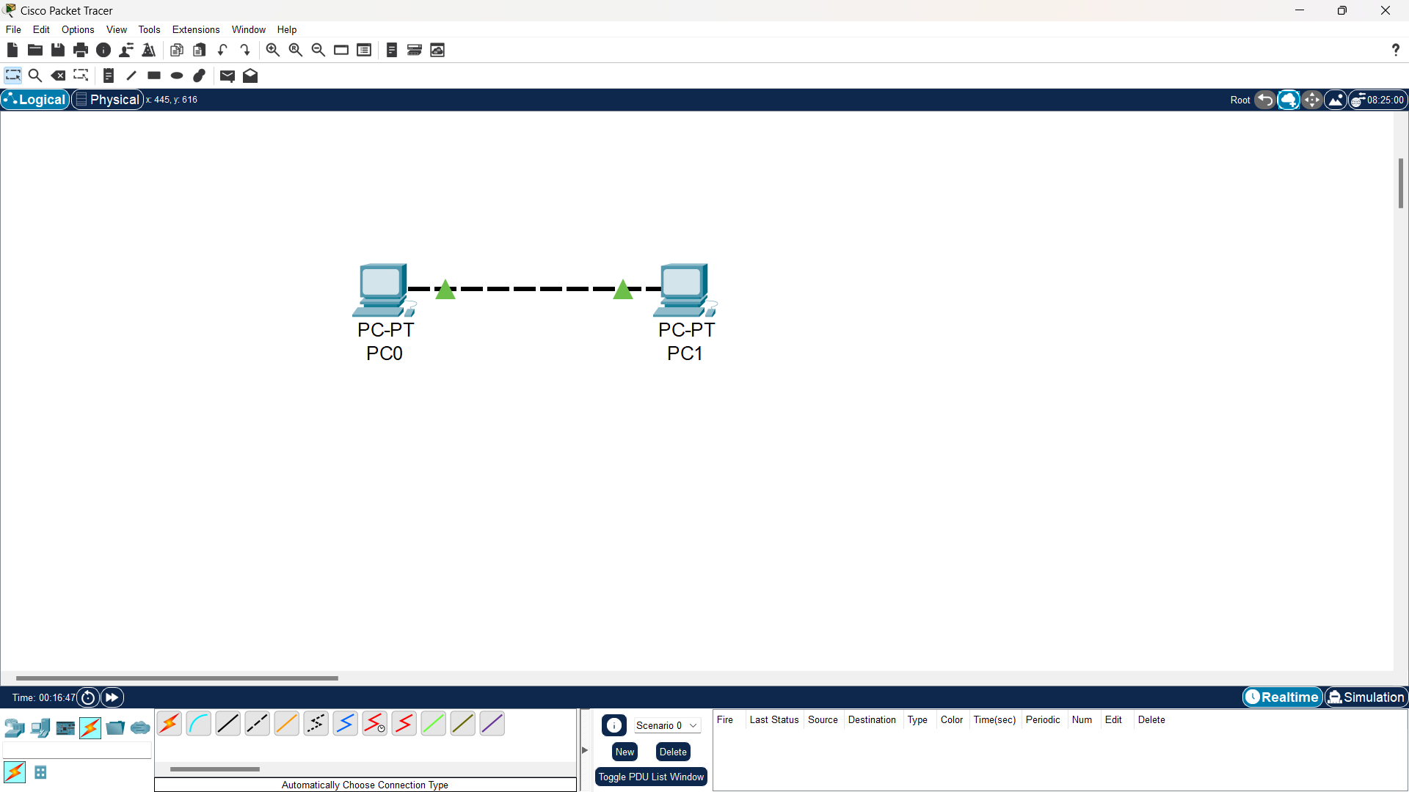

1. After connecting the PCs, assign an IP address to the PCs by clicking into the PC icon then Desktop and finally click to IP Configuration and adjust the IP address as an example below:

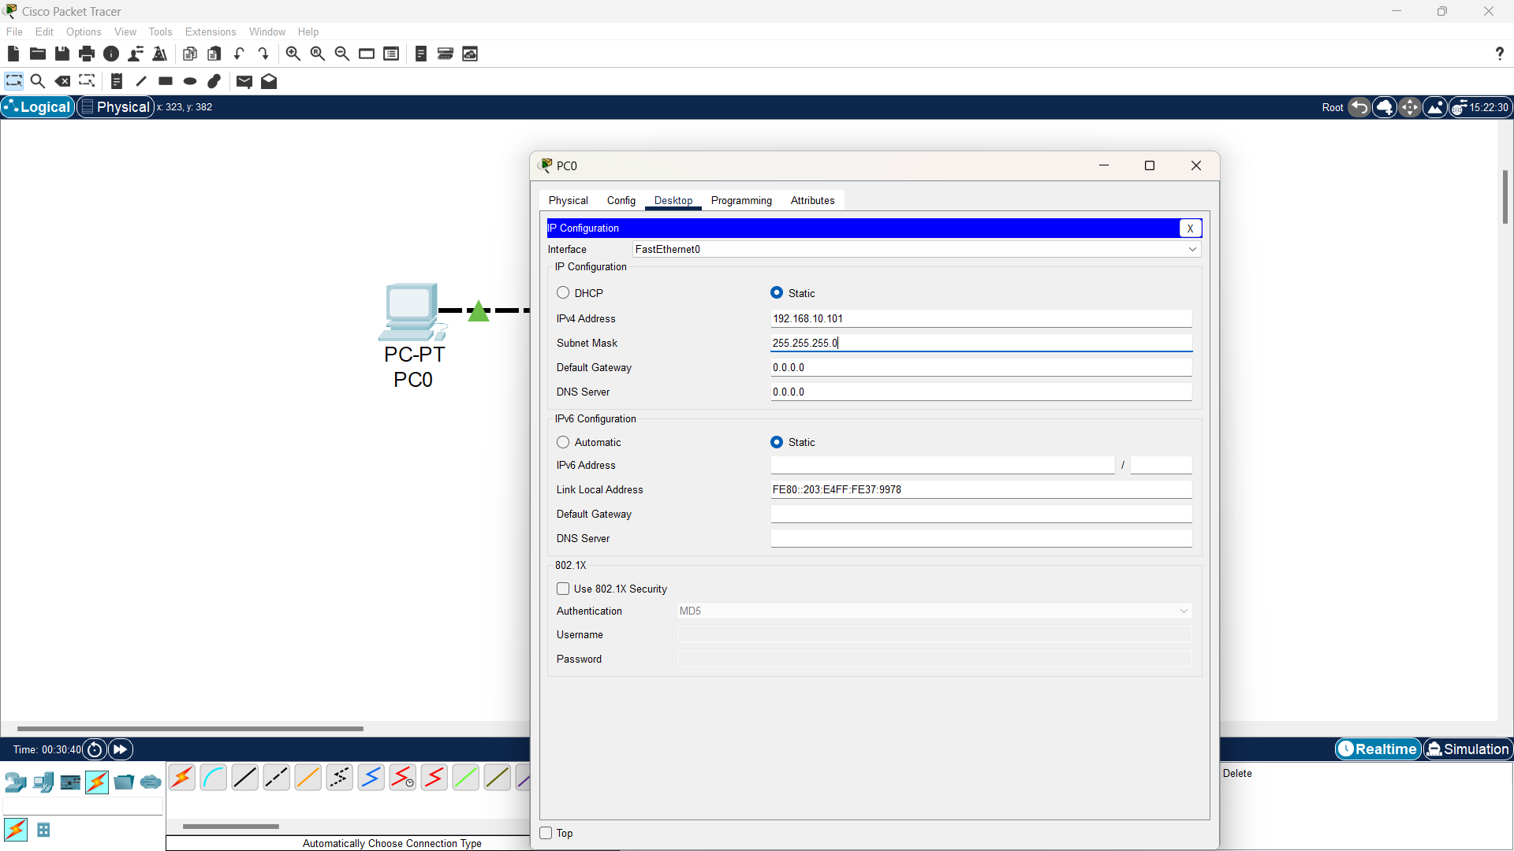

1. Repeat the same IP assigning process for another PC i.e., PC1 with a different host IP address but on the same network.

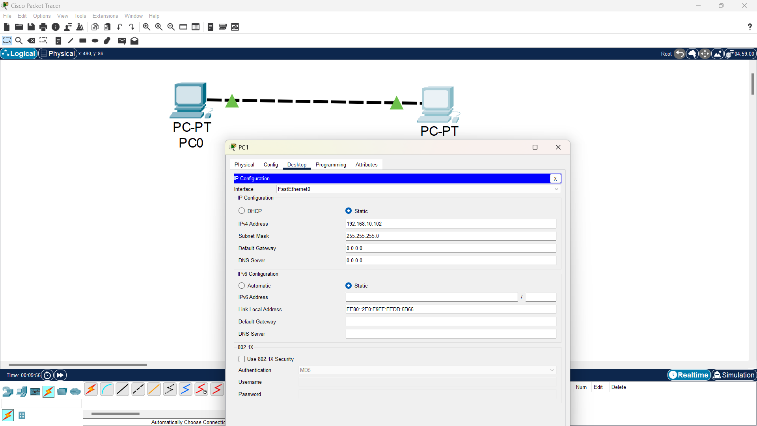

**VERIFICATION:**

If two computers are connected to the same network and have IP addresses within the same network segment, they should be able to communicate with each other. You can test this connectivity by using the "ping" command in the Command Prompt or terminal.

In the example above, if PC0 has the IP address 192.168.10.101 and PC1 has the IP address 192.168.10.102, you can open the Command Prompt on PC0 and type the following command:



If PC1 is indeed reachable and properly configured, it will respond with a message similar to "reply from 192.168.10.102," indicating a successful communication. However, if you receive a "timed out" message, it suggests that the two computers are unable to communicate. To ensure successful communication, make sure that the IP addresses of both computers are in the same network segment.



In this case, they should have the same network address (192.168.10) with different host numbers (101 and 102 in above example). The host numbers can range from 1 to 255, as long as they are unique within the network segment.

**CONCLUSION:**

Peer-to-peer communication becomes possible by assigning IP addresses and ensuring computers belong to the same network. With the unique IP addresses, computers can identify and locate each other within the network, while being part of the same network segment allows them to establish connections and exchange data effectively.

**LAB 4.2: BUILD A LAN WITH A SWITCH AND HUB IN PACKET TRACER**

**OBJECTIVE:**

* To construct and understand a LAN with a Switch and Hub using Packet Tracer.
* To understand how switch and hub works on LAN.

**TOOLS USED:**

* Cisco Packet Tracer

**TOPOLOGY:**

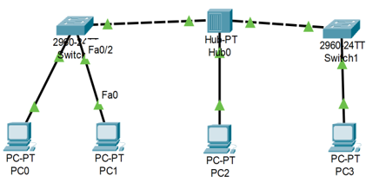

**BACKGROUND:**

Building a Local Area Network (LAN) using a switch and hub in Packet Tracer involves setting up a network infrastructure that enables connectivity and data exchange between multiple devices. A switch is a networking device that connects devices within a network, allowing them to communicate directly with each other. On the other hand, a hub is a simple networking device that broadcasts incoming data packets to all connected devices within the network, regardless of the intended recipient. However, in modern networking, switches have largely replaced hubs due to their superior performance and efficiency in managing network traffic.

**PROCEDURE:**

1. After opening the Cisco packet tracer, click on End devices from bottom left icon menus and add four PCs, and a hub with two switches being placed on both sides into the screen of the simulator.

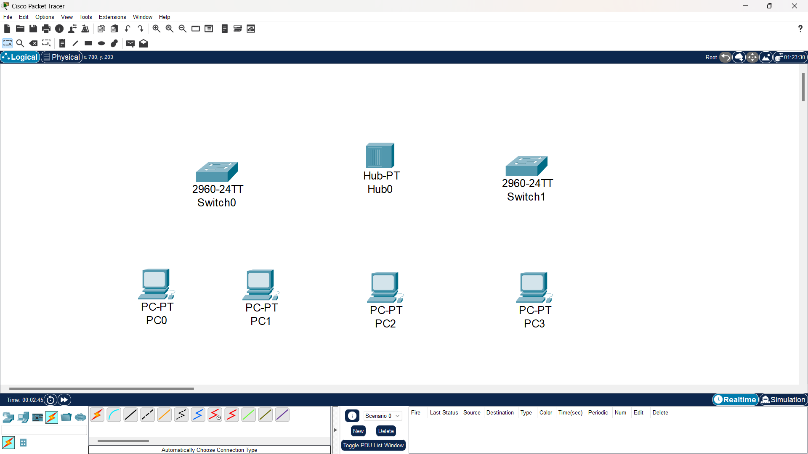

1. Now, connect all PCs, Hub and switches with copper straight cable by selecting it through the cable’s menu from the bottom left menus in the simulator and check if wires give green signal which means devices are ready to communicate.

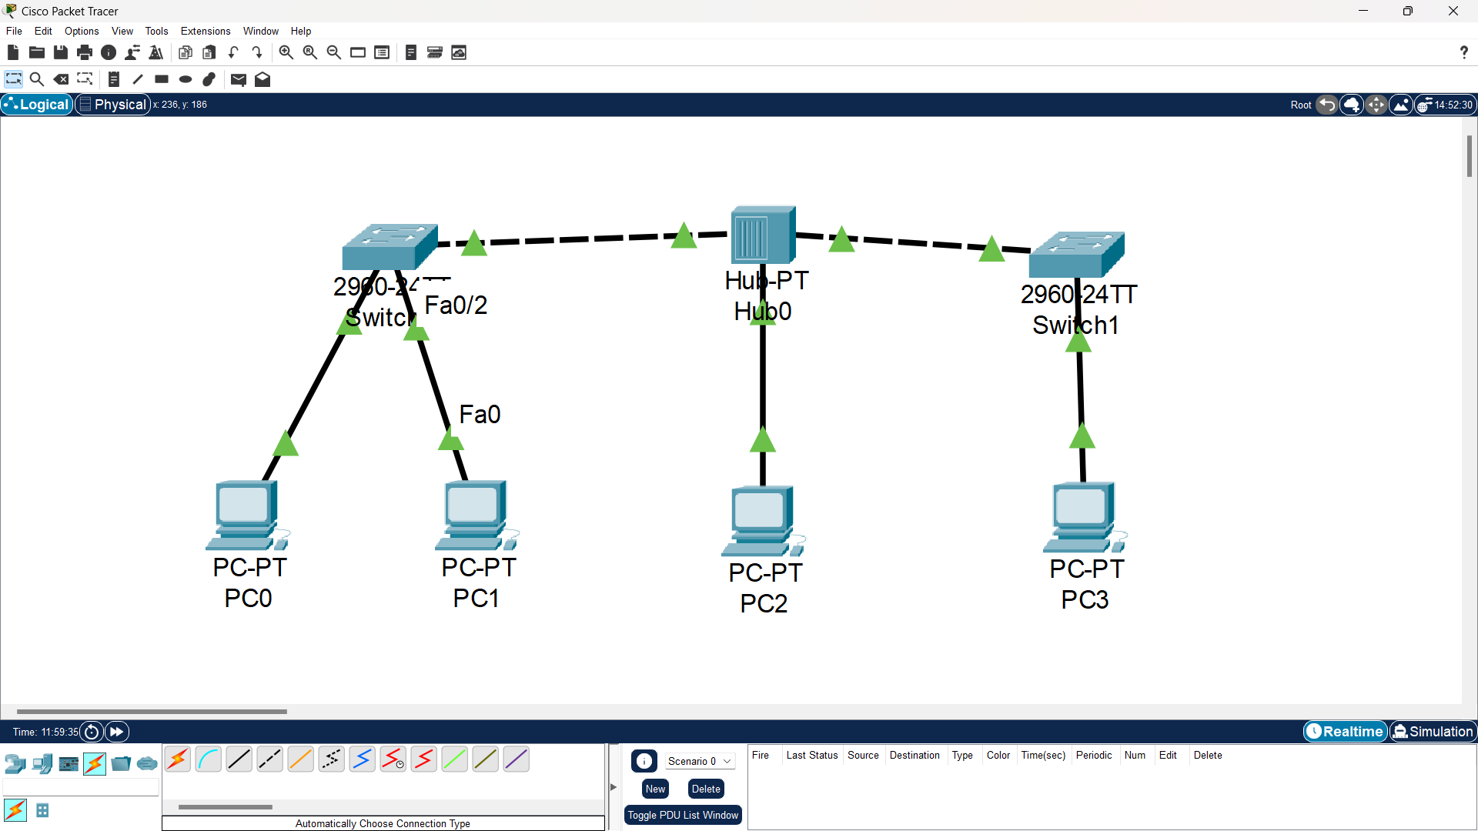

1. Now, assign a unique IP address to each PC by clicking on each PC, going to the Desktop section, and clicking on "IP Configuration" to provide the desired IP address. The following table is the list of Ip Addresses which I provided.

|  |  |  |
| --- | --- | --- |
| PC | IP Address | Subnet Mask |
| PC0 | 192.168.10.20 | 255.255.255.0 |
| PC1 | 192.168.10.21 | 255.255.255.0 |
| PC2 | 192.168.10.22 | 255.255.255.0 |
| PC3 | 192.168.10.23 | 255.255.255.0 |

1. Test the connectivity between the PCs by opening the Command Prompt on a PC, typing "ping" followed by the IP address of the target PC, and pressing Enter to execute the ping command.

**VERIFICATION:**

After establishing the connections between all the PCs, hub, and switches, and assigning IP addresses to each PC as described in step 4, I proceeded to verify the connectivity between devices by using the ping command.



Specifically, I used PC0 to ping the IP address of PC3 within the network. I successfully received a reply from PC3, confirming successful communication between the two devices.

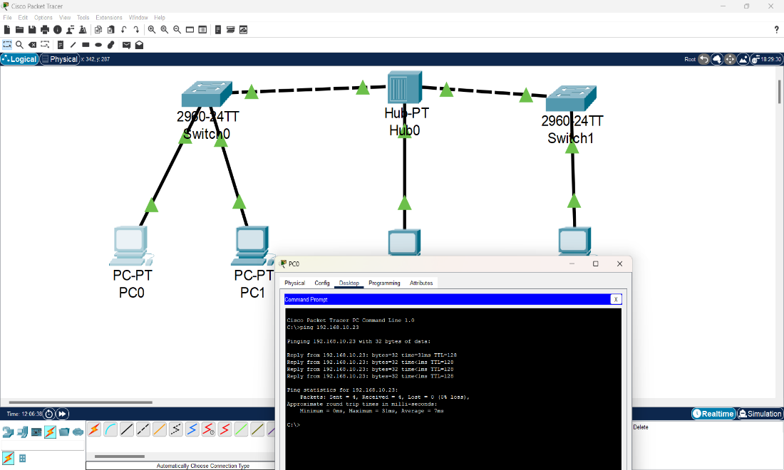

**CONCLUSION:**

In conclusion, the LAN setup with a switch and hub in Packet Tracer was successfully completed. By establishing connections between all the PCs, hub, and switches, and assigning unique IP addresses to each PC, the network infrastructure was properly configured. The verification step, which involved using the ping command to test connectivity between devices, yielded positive results. Specifically, PC0 successfully pinged the IP address of PC3 and received a reply, indicating successful communication. This confirms that the LAN is functioning correctly and allows for seamless data exchange and connectivity between devices in the network.

**LAB 4.3: BUILD A WLAN WITH A SWITCH AND ACCESS POINTS IN PACKET TRACER**

**OBJECTIVE:**

* Understanding the configuration of access points, setting up security protocols, and
* ensuring reliable wireless connectivity for devices within the WLAN.

**TOOLS USED:**

* Packet Tracer

**BACKGROUND:**

Building a WLAN (Wireless Local Area Network) with a switch and access points in Packet Tracer involves creating a network infrastructure that enables wireless connectivity for devices. An access point acts as a central hub that allows wireless devices to connect to the network. It facilitates communication between devices and the switch, which serves as the backbone of the network. The access points provide wireless coverage, allowing devices to connect and transmit data without the need for physical cables.

**TOPOLOGY:**

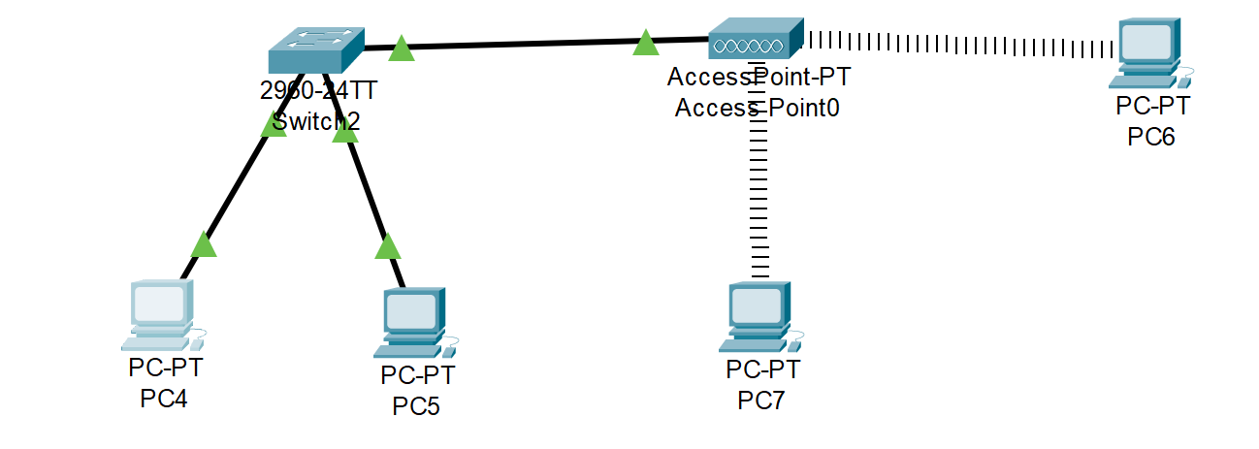

**PROCEDURE:**

1. After opening the Cisco packet tracer, click on End devices from bottom left icon menus and add four PCs, and a Switch and an Access Point into the screen of the simulator.

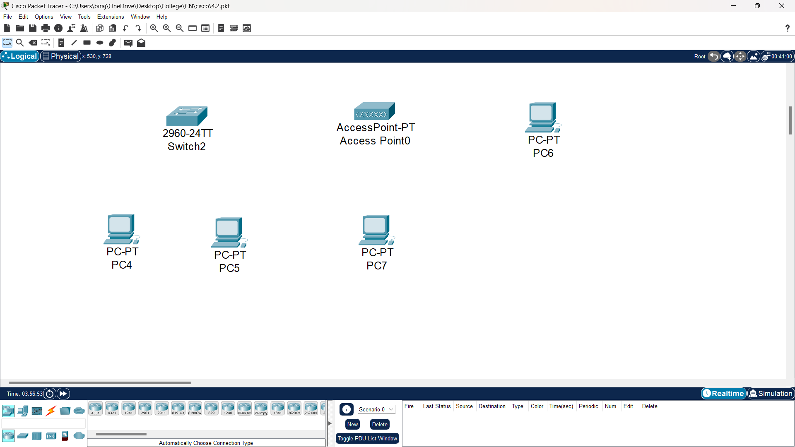

1. Now, connect all PCs, Access Point and Switch with copper straight cable by selecting it through the cables from the bottom left menus in the simulator and check if wires give green signal which means devices are ready to communicate.
2. To connect PCs with Access Point

* First Power Off PCs and remove the MODULES

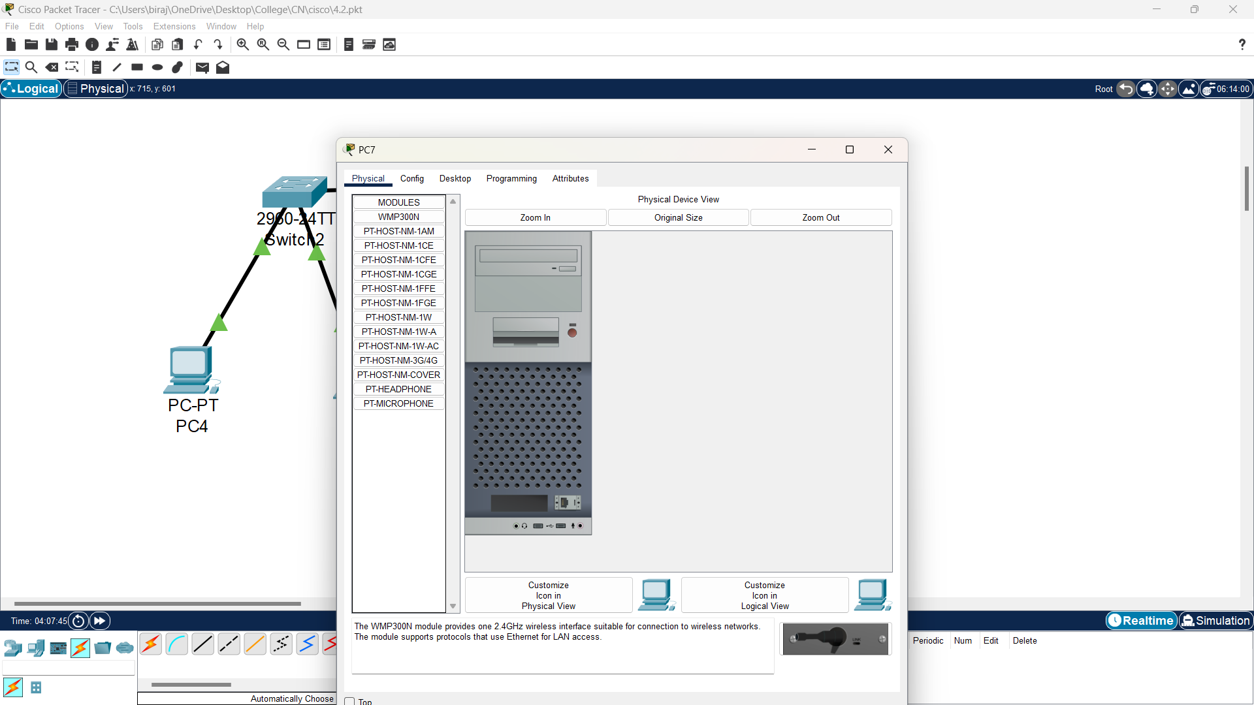

* Now add WMP300N and then power on the PC.

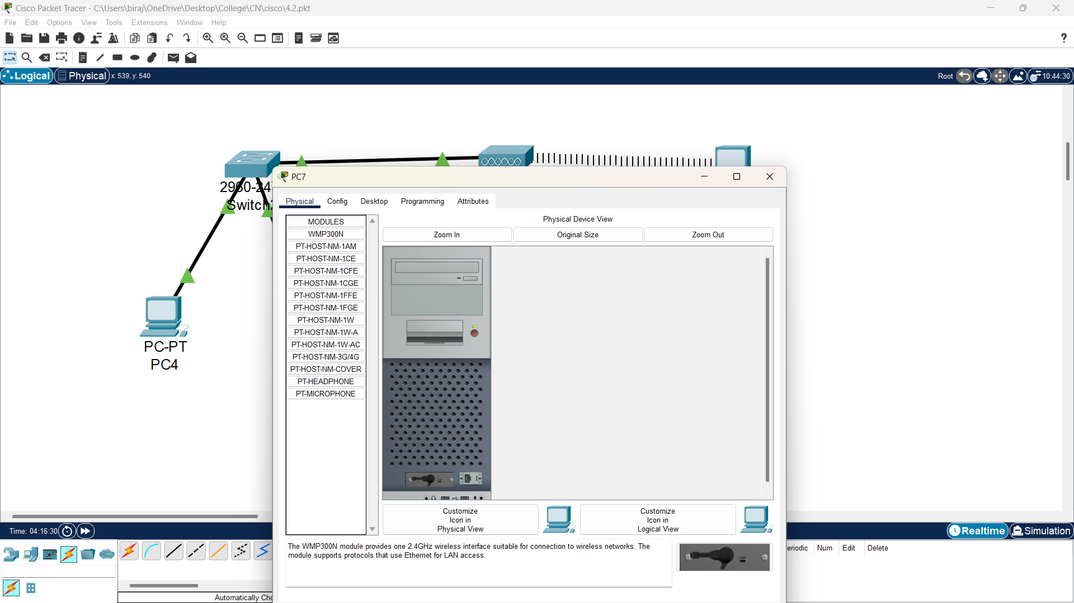

* WMP300N helps for wireless connection of PCs and Access Point. And IP address of PCs are configured by AC.

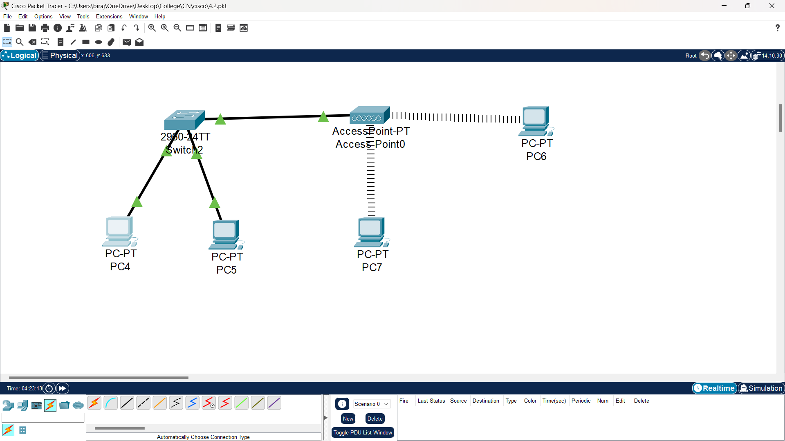

1. Now, assign a unique IP address to each PC by clicking on each PC, going to the Desktop section, and clicking on "IP Configuration" to provide the desired IP address. Static IPv4 addressing is used in the PC6 and PC7. The following table is the list of IP Addresses which I provided.

|  |  |  |
| --- | --- | --- |
| PC | IP Address | Subnet Mask |
| PC4 | 192.168.10.50 | 255.255.255.0 |
| PC5 | 192.168.10.51 | 255.255.255.0 |
| PC6 | 192.168.10.52 | 255.255.255.0 |
| PC7 | 192.168.10.53 | 255.255.255.0 |

1. Test the connectivity between the PCs by executing the ping command opening the Command Prompt on a PC, typing "ping" followed by the IP address of the target PC.

**VERIFICATION:**

To verify the connection between the PCs, hub and Access Point, I used PC5 to ping the IP address of PC6 within the network. I successfully received a reply from PC6, confirming successful communication between the two devices.

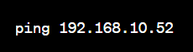



**CONCLUSION:**

In conclusion, the WLAN setup with a switch and access points in Packet Tracer was successfully implemented. By creating the network infrastructure and configuring the access points, wireless connectivity was established for devices within the network. The verification step, which involved using PC5 to ping the IP address of PC6, demonstrated that the connection between the PCs, hub, and access points was functioning correctly. The successful receipt of a reply from PC6 confirmed the successful communication and validated the WLAN setup.